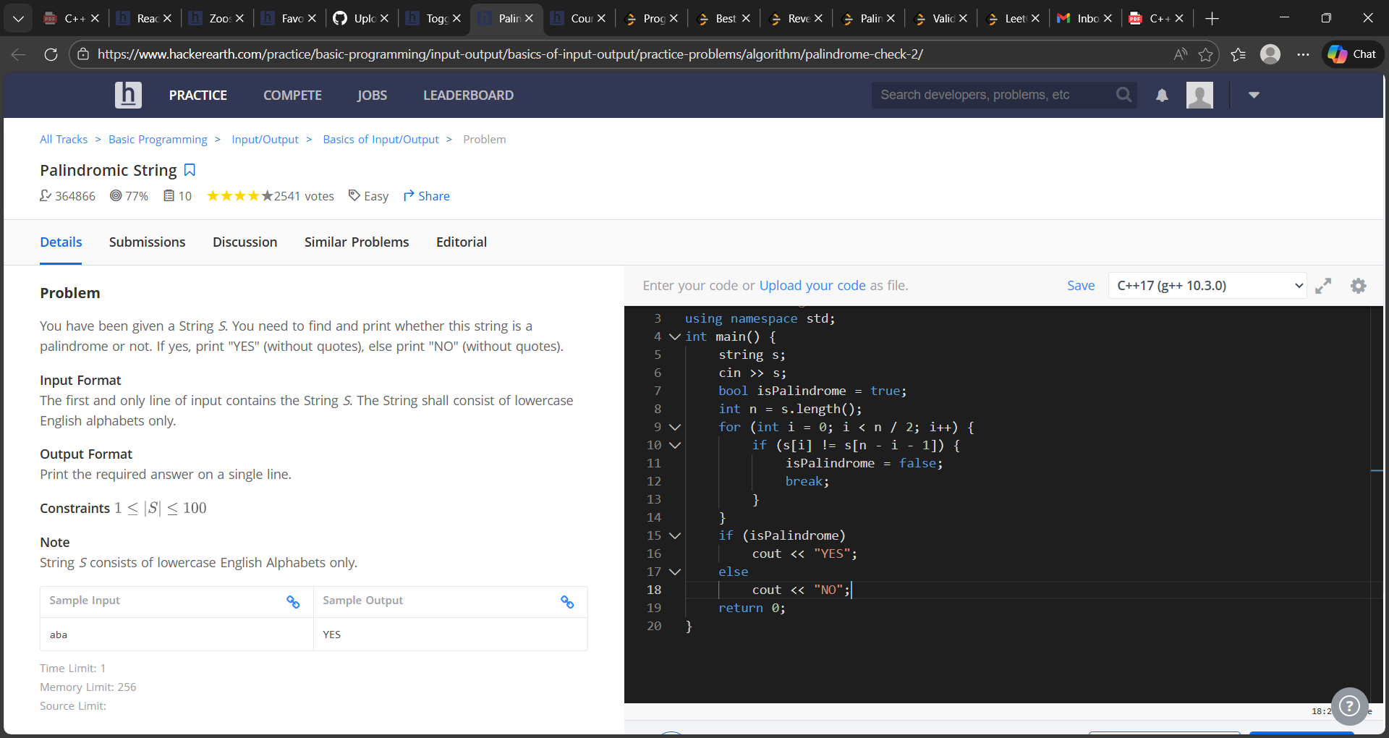

#include <iostream>
#include <string>
using namespace std;
int main() {
string s;
cin >> s;
bool isPalindrome = true;
int n = s.length();
for (int i = 0; i < n / 2; i++) {
if (s[i] != s[n - i - 1]) {
isPalindrome = false;
break;
}
}
if (isPalindrome)
cout << "YES";
else
cout << "NO";
return 0;
}

